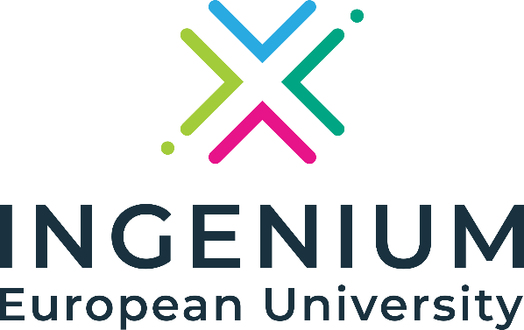



Call for Academic Working Groups – INGENIUM Flagship Joint Programmes

Application form

  - Name:

  - Which programme are you interested in?
- Bachelor Programme in Entrepreneurship and Innovation
- Joint Master Programme in Advanced Practice Nursing in Acute Care
- Joint Master Programme in Artificial Intelligence
- Joint Master Programme in Chemical and Biochemical Process Technology
- Joint Master Programme in Sustainable Development
  - Are you submitting this application on behalf of:
- Individual academic
- Department
- Faculty/School
- Other

  - Institution:

  - Have you gotten approval from your institution?

  - What is your previous experience in the topic of the programme?

  - Do you have (as a faculty, department and/or individual academic) previous experience in international collaborative programmes?

  - What are your main motivations to become a part of this programme?

